Eagle Owls Electricity – Knowledge Organiser
Key Vocabulary
Bulb: a component that uses electricity to emit light.  Buzzer: a component in a circuit that makes a loud noise.  Cell: single battery.  Circuit: A collection of components including: a battery for power, wire to pass the electricity around the circuit, a component (such as a bulb) for the battery to power and wire to join the component back to the battery. *See picture  Circuit diagram: A drawing of a circuit using the symbols below. | Components: equipment used in an electrical circuit.  Motor: a component in a circuit that changes electrical energy into movement, e.g. make a fan spin.  LED bulb (light emitting diode): is a type of bulb that emits more light for less electrical power.  Switch: open / closed. An open switch means the switch is turned off, and the circuit is incomplete. A closed switch means the switch is turned on and the circuit is complete.
Circuit Circuit Diagram  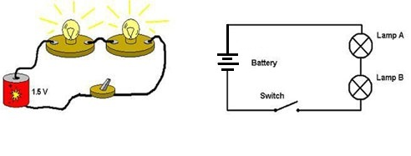 |  | Circuit diagram symbols  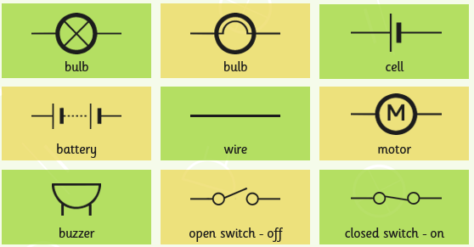
Unlock more knowledge by visiting:
https://www.bbc.co.uk/bitesize/topics/zj44jxs
https://www.dkfindout.com/uk/science/electricity/circuits/
and watch:
https://www.bbc.co.uk/teach/class-clips-video/science-ks2-how-do-circuits-work/zrtgkhv

