Eagle Owls ROMANS – Knowledge Organiser
Key Vocabulary | Useful websites and books
empire: a group of countries led by one ruler (emperor / empress) or government  invention: a unique / new idea, device or method  emperor: ruler of an empire  mosaic: a pattern or image made of small pieces of stone, glass or ceramic  legion: large section of the Roman army (about 5000 soldiers)  artefact: an object made by people of historical or cultural importance  Roman Empire: the land that was controlled by the Romans  remains (historical): historical or archaeological relics  legacy  soldier: a member of an army | BBC Bitesize: https://www.bbc.co.uk/bitesize/guides/zfqsgk7/video  DK Findout - Ancient Rome: https://www.dkfindout.com/uk/history/ancient-rome/  BBC Bitesize: https://www.bbc.co.uk/bitesize/topics/zwmpfg8  There is a selection of books in our classroom including: Horrible Histories Rotten Romans
 | 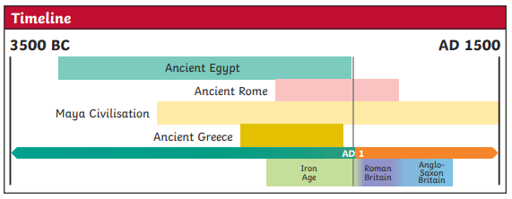
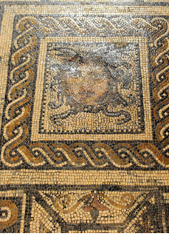
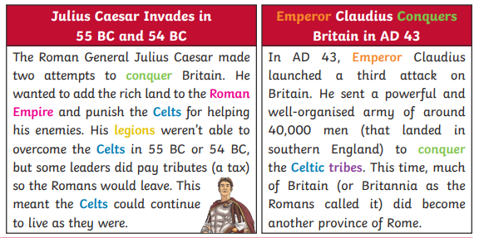

The floors of Roman buildings were often richly decorated with mosaics. Mosaics have been found that show scenes of history, as well as everyday Roman life. Mosaic floors were a statement of how wealthy and important you were.
Roman Mosaics

