Eagle Owls EARTH AND SPACE – Knowledge Organiser
Key Vocabulary | Famous Scientists
Gravity: a pulling force exerted by the Earth  Moon: a natural satellite that orbits the Earth and other planets  Orbit: to move in a regular curved path around another object  Planet: a large object (round of nearly round) that orbits a star  Phases of the Moon: the repeating cycle of the changing shape of the moon as seen from Earth  Rotation: spinning  Solar system: the sun and everything that orbits or travels around it  Sphere: a round 3D shape in the shape of a ball  Star: a giant ball of gas held together by its own gravity (sun)  Time zones: there are 24 time zones around the Earth approximately an hour apart | 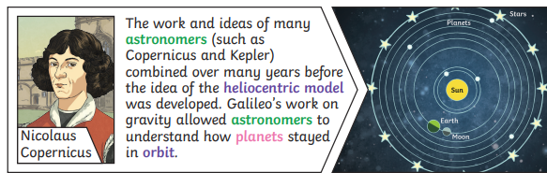
Useful websites and books:
https://www.dkfindout.com/uk/space/
https://www.bbc.co.uk/bitesize/topics/zkbbkqt
https://www.bbc.co.uk/iplayer/episodes/p07922lr/the-planets (5 great prorammes to watch)
The following books are availible in our class: In Focus: Space, Planetarium, Solar Systwm (Barefoot Books) and 100 Facts About Space.
